**POUVARET** 2015-2016

**Line**  Virginia GARDNER

UFR IM²AG (English Teacher)

M1 Info

**READING FILE**

1. **FREE WRITING**

**Topic : Technology in our lives**

Whether we wanted it or not, our everyday life has been progressively invaded by new technologies. How could we explain it ?

Well, first, we should explain why the new technologies are evolving and invented in the first place.

Most of the time, these new technologies have the purpose to entertain, to reduce en effort (or completely remove it), to help people doing things more efficiently and more rapidly, to learn new knowledge, etc. Therefore, can we say that they embellish our lives ? Could we live without all of them ?

For now, they are really useful in our lives and I think that most people would find it difficult to leave them behind. Also, a lot of these technologies need an electrical supply, so what if we were to run out of electricity ? We got used to them in no time but I don’t think that we would get used to live without them in the same amount of time. Of course in the end, we would get used to it but I think it would be difficult for some of us, and even harder for the generations to come.

One question that we could ask ourselves is : are we slaves of technology ? We seem to forget what our life was without it. We all got kind of addicted to it but we must admit that it tends to be really useful in our everyday life. Every task is faster, more efficient, we can get the news from all over the world by one click or one zap on the TV. We can talk to people even if they’re not in the same country as we are.

There are so many tools that the technology brings to us. Let’s just hope that it will continue to help people in their lives and not make them lazier. We should not forget what it was like when we didn’t have all of that technology.

1. **READING FILE FOR IN-CLASS WORK**

* **ARTICLE 1**

**Hacked Kinect controller game changer for Parkinson’s**

**30 April 2015**

**Amin and Dr Banitsas**

Scientists at Brunel University London have developed a system for Parkinson’s sufferers to counter two of the most common and distressing symptoms of the degenerative disease.

Many patients are afflicted by freezing of gait (FOG) where suddenly, in mid-stride, the muscles freeze and they are left unable to move forward or they simply fall over.

Previous research shows that giving visual clues such as projecting lines ahead on the floor “unfreezes” the muscles but current equipment has to be worn.

But Dr Konstantinos Banitsas and PhD candidate Amin Amini Maghsoud Bigy have turned Microsoft’s Kinect computer games controller into a system that can be installed into a patient’s own home.

Linked to a ceiling mounted laser, the Kinect can not only project prompt lines when the software detects a FOG incident but if a patient falls, the system not only detects that but also automatically triggers a video conferencing call.

Said Dr Banitsas: “All the other systems require a patient to wear sensors and power packs where our solution is unobtrusive and covers a whole room.

“By mounting the laser guide marker on the ceiling it can provide the visual clues in any direction. And it is only activated when a FOG incident occurs instead of having to be worn constantly.

“The system has already passed proof of concept stage and we will shortly begin patient trials.”

**Story Source:**

The above post is reprinted from [materials](http://www.brunel.ac.uk/news-and-events/news/news-items/ne_419734) provided by [**Brunel University**](http://www.brunel.ac.uk/). *Note: Materials may be edited for content and length.*

http://www.sciencedaily.com/releases/2015/04/150430082712.htm

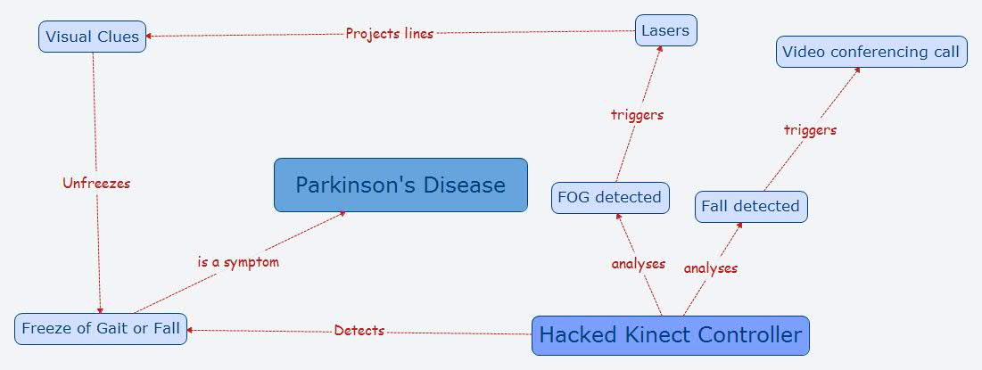

* **ARTICLE 2**

# Video game teaches kids how to code

Date:

September 10, 2014

Source:

University of California - San Diego

Summary:

Computer scientists have successfully funded on Kickstarter a new and improved version of CodeSpells, a first-person player game they developed that teaches players how to code.

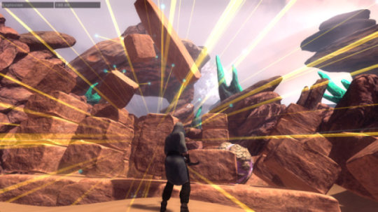

A screen shot for the video game.

Credit: Image courtesy of University of California - San Diego

Computer scientists at the University of California, San Diego have successfully funded on Kickstarter a new and improved version of CodeSpells, a first-person player game they developed that teaches players how to code.

The game's previous iteration, developed by UC San Diego computer science Ph.D. students Sarah Esper and Stephen Foster, has been in use in dozens of schools throughout the world for more than a year. The researchers have been using the game as a platform to learn about the best ways to teach children how to code. They have presented their findings at a wide range of academic conferences, including the upcoming Koli Calling International Conference on Computing Education Research Nov. 20 to 23 in Koli, Finland.

In this latest paper, "CodeSpells: Bridging Educational Language Features with Industry-Standard Languages," the researchers demonstrate that after playing CodeSpells for either four hours over four weeks or 10 hours over seven days, children ages 8 to 12 were able to write code by hand in Java.

"It is the goal of CodeSpells to provide a rich experience of computer science education to students who may not have access to an educator," Esper said.

Researchers now want to make the game more attractive and more fun to play. But they need funds to improve the game's graphics and coding interface. Enter Kickstarter, where the project has already met and exceeded its $50,000 fundraising goal.

"We want the game to be educational, but our biggest goal is to make sure it's fun," Foster said.

He and Esper have co-founded ThoughtSTEM, along with UC San Diego biochemistry Ph.D. student Lindsey Handley, to teach children ages 8 to 18 how to code, via onsite classes and video games, including CodeSpells and Minecraft.

In its previous iteration, CodeSpells sent players on quests, which helped them master spells, written in Java. This new version is more open-ended much like Minecraft -- a so-called sandbox game. The players are wizards that can modify the world around them at will. They can build mountains and valleys, levitate objects and start fires. They do so by using Blocky, a visual programming language created by Google, or Javascript.

The hope is that players will come up with their own quests. Researchers also hope that as players tinker with the game, they'll come up with their own exciting spells and share those. The goal is to create a vibrant online community, much like the one that has developed around Minecraft.

The game will feature several modes out of the box, but players will be able to create their own modes too. They'll have the tools to create everything from modes to survive in the wilderness to modes to balance an eco-system. They can even create multi-player magic-based sports to play with their friends.

The game will feature four elements: earth, fire, water and air, which the players can manipulate via spells. So far, computer scientists have completed an early version of gameplay for earth magic. The Kickstarter will fund the development of magic for fire, air and water, with an alpha version to be released on Christmas Day 2014, a beta version in June 2015, and the final copy of the game's creative mode to be released September 2015.

If the Kickstarter exceeds its $50,000 goal, the game's multiplayer functions will be enhanced. In addition, the game will add a fifth element, life, which would give wizards control over animals and plants within the game. That feature would be released in summer 2016. By early 2017, players would be able to create their own species and custom characters within the game.

Rewards for the Kickstarter range from a digital copy of CodeSpells for a $10 donation to access to district-wide licenses for CodeSpells in alpha and beta versions and computational thinking courses to a teacher at each school within a school district for a $5,000 donation.

**Story Source:**

The above post is reprinted from [materials](http://www.jacobsschool.ucsd.edu/news/news_releases/release.sfe?id=1568) provided by [**University of California - San Diego**](http://www.ucsd.edu/). Note: Materials may be edited for content and length.

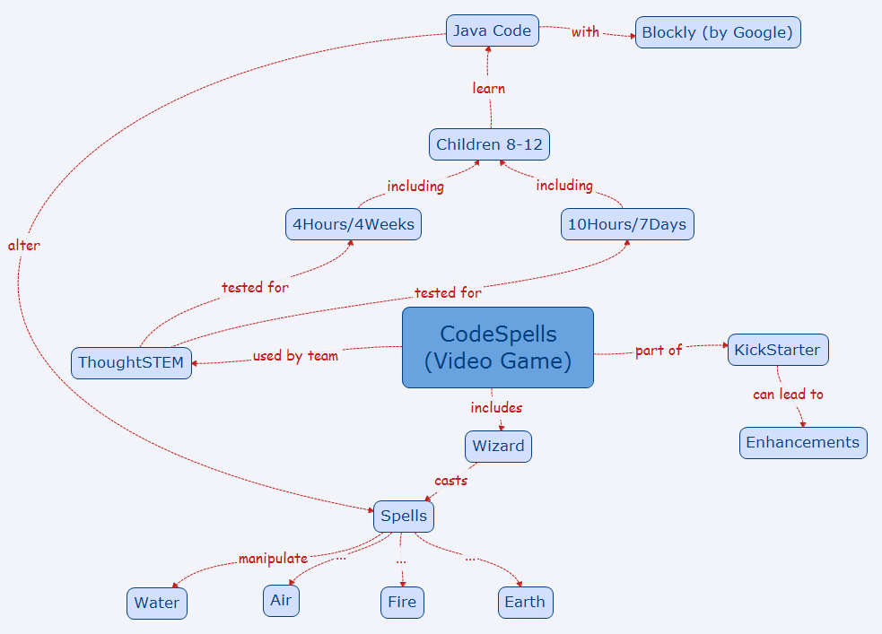

* **ARTICLE 3**

**What types of video games improve brain function?**

Date:

October 1, 2015

Source:

SAGE Publications

Summary:

From 'brain games' designed to enhance mental fitness, to games used to improve real-world problems, to games created purely to entertain, today's video games can have a variety of potential impacts on the brain. A new article argues that it is the specific content, dynamics, and mechanics of individual games that determine their effects on the brain and that action video games might have particularly positive benefits.

The article is published in the new issue of *Policy Insights from the Behavioral and Brain Sciences*, a Federation of Associations in Behavioral & Brain Sciences (FABBS) journal published by SAGE.

"The term video games refers to thousands of quite disparate types of experiences, anything from simple computerized card games to richly detailed and realistic fantasy worlds, from a purely solitary activity to an activity including hundreds of others, etc. A useful analogy is to the term food -- one would never ask, 'What is the effect of eating food on the body?' Instead, it is understood that the effects of a given type of food depend on the composition of the food such as the number of calories; the percentage of protein, fat, and carbohydrates; the vitamin and mineral content; and so on," the researchers wrote.

Analyzing science on the cognitive effects of video games, Drs. C. Shawn Green and Aaron R. Seitz wrote that action video games- games that feature quickly moving targets that come in and out of view, include large amounts of clutter, and that require the user to make rapid, accurate decisions -- have particularly positive cognitive impacts, even when compared to "brain games," which are created specifically to improve cognitive function.

"Action video games have been linked to improving attention skills, brain processing, and cognitive functions including low-level vision through high-level cognitive abilities. Many other types of games do not produce an equivalent impact on perception and cognition," the researchers commented. "Brain games typically embody few of the qualities of the commercial video games linked with cognitive improvement."

Green and Seitz noted that while action games in particular have not been linked to problems with sustaining attention, research has shown that total amount of video game play predicts poorer attention in the classroom. Furthermore, video games are known to impact not only cognitive function, but many other aspects of behavior -- including social functions -- and this impact can be either positive or negative depending on the content of the games.

"Modern video games have evolved into sophisticated experiences that instantiate many principles known by psychologists, neuroscientists, and educators to be fundamental to altering behavior, producing learning, and promoting brain plasticity. Video games, by their very nature, involve predominately active forms of learning (i.e., making responses and receiving immediate informative feedback), which is typically more effective than passive learning."

**Story Source:**

The above post is reprinted from [materials](https://us.sagepub.com/en-us/nam/press/what-types-of-video-games-improve-brain-function) provided by [**SAGE Publications**](http://www.sagepub.com). *Note: Materials may be edited for content and length.*

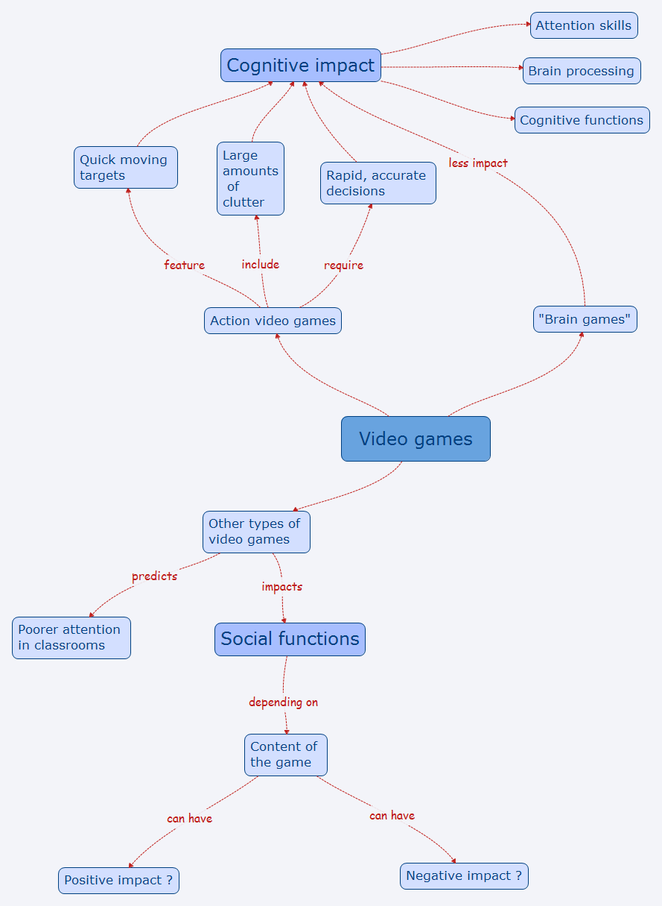

* **ARTICLE 4**

**Inflammation in the brain is linked to risk of schizophrenia, study finds**

Date:

October 16, 2015

Source:

MRC Clinical Sciences Centre/Institute of Clinical Sciences (ICS) Faculty of Medicine, Imperial Coll

Summary:

A new study is the first to find that immune cells are more active in the brains of people at risk of schizophrenia as well as those already diagnosed with the disease.



PET imaging signal in healthy volunteers, high-risk subjects and patients with schizophrenia showing a stepwise elevation in microglial activity (orange) as severity of illness increases.

*Credit: MRC's Clinical Sciences Centre*

Study finds inflammation in the brain is linked to risk of schizophrenia

A study, published in the *American Journal of Psychiatry*, is the first to find that immune cells are more active in the brains of people at risk of schizophrenia as well as those already diagnosed with the disease.

The finding could completely change our current understanding of schizophrenia, raising the possibility that testing people most at risk of the disorder ahead of time could allow them to be treated early enough to avoid its most severe symptoms.

Researchers at the Medical Research Council's (MRC) Clinical Sciences Centre, based at Imperial College London, in collaboration with colleagues at King's College London used positron emission tomography (PET) scans to measure levels of activity of immune cells in the brain. These cells, known as microglia, respond to damage and infection in the brain, and are also responsible for rearranging the connections between brain cells so that they work as well as possible; a process known as pruning.

The team tested a group of 56 people including those already diagnosed with schizophrenia, those at risk of the disease and those with no symptoms or risk of the disorder. They found that activity levels of microglia in the brain increased according to the severity of symptoms in people with schizophrenia and that people with diagnosed schizophrenia had high levels of activity of these immune cells in their brain.

Peter Bloomfield, lead author of the study at the MRC Clinical Sciences Centre, said: "Our findings are particularly exciting because it was previously unknown whether these cells become active before or after onset of the disease.

"Now we have shown this early involvement, mechanisms of the disease and new medications can hopefully be uncovered."

Dr Oliver Howes, head of the psychiatric imaging group at the MRC Clinical Sciences Centre, added: "Schizophrenia is a potentially devastating disorder and we desperately need new treatments to help sufferers, and ultimately to prevent it.

"This is a promising study as it suggests that inflammation may lead to schizophrenia and other psychotic disorders. We now aim to test whether anti-inflammatory treatments can target these. This could lead to new treatments or even prevention of the disorders altogether."

Professor Hugh Perry, Chair of the Neuroscience and Mental Health Board at the MRC, added "Schizophrenia, like other mental health disorders, is a complex disease that we know is caused by an interplay of genetic, behavioural and other contributing factors.

"This study adds to a growing body of research that inflammation in the brain could be one of the factors contributing to a range of disorders -- including Alzheimer's, schizophrenia and depression -- and with this new knowledge comes the hope of life-changing treatments."

**Story Source:**

The above post is reprinted from [materials](http://csc.mrc.ac.uk/study-finds-inflammation-brain-linked-risk-schizophrenia/) provided by [**MRC Clinical Sciences Centre/Institute of Clinical Sciences (ICS) Faculty of Medicine, Imperial Coll**](http://csc.mrc.ac.uk/). *Note: Materials may be edited for content and length.*

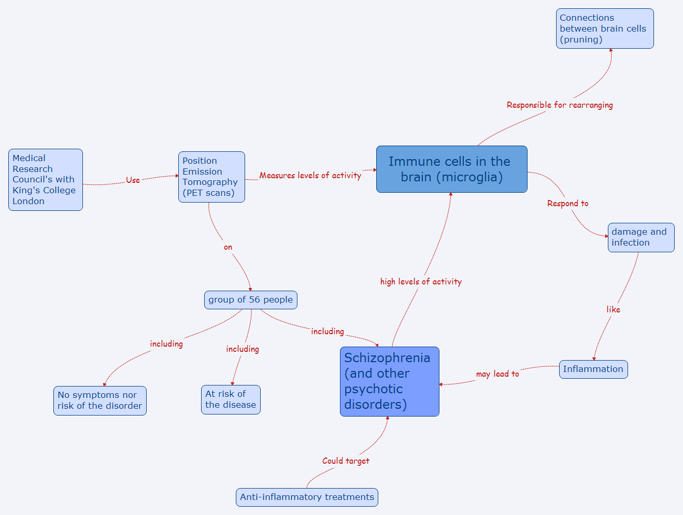

* **ARTICLE 4**

**A network of artificial neurons learns to use human language**

**A computer simulation of a cognitive model entirely made up of artificial neurons learns to communicate through dialogue starting from a state of tabula rasa**

Date:

November 11, 2015

Source:

University of Sassari

Summary:

A group of researchers has developed a cognitive model, made up of two million interconnected artificial neurons, able to learn to communicate using human language starting from a state of 'tabula rasa', only through communication with a human interlocutor. This research sheds light on the neural processes that underlie the development of language.



The ANNABELL model is a cognitive architecture entirely made up of interconnected artificial neurons, able to learn to communicate using human language starting from a state of 'tabula rasa' only through communication with a human interlocutor.

*Credit: Bruno Golosio*

**A group of researchers from the University of Sassari (Italy) and the University of Plymouth (UK) has developed a cognitive model, made up of two million interconnected artificial neurons, able to learn to communicate using human language starting from a state of "tabula rasa," only through communication with a human interlocutor. The model is called ANNABELL (Artificial Neural Network with Adaptive Behavior Exploited for Language Learning) and it is described in an article published in the international scientific journal *PLOS ONE*. This research sheds light on the neural processes that underlie the development of language.**

How does our brain develop the ability to perform complex cognitive functions, such as those needed for language and reasoning? This is a question that certainly we are all asking ourselves, to which the researchers are not yet able to give a complete answer. We know that in the human brain there are about one hundred billion neurons that communicate by means of electrical signals. We learned a lot about the mechanisms of production and transmission of electrical signals among neurons. There are also experimental techniques, such as functional magnetic resonance imaging, which allow us to understand which parts of the brain are most active when we are involved in different cognitive activities. But a detailed knowledge of how a single neuron works and what are the functions of the various parts of the brain is not enough to give an answer to the initial question.

We might think that the brain works in a similar way to a computer: after all, even computers work through electrical signals. In fact, many researchers have proposed models based on the analogy brain-is-like-a-computer since the late '60s. However, apart from the structural differences, there are profound differences between the brain and a computer, especially in learning and information processing mechanisms. Computers work through programs developed by human programmers. In these programs there are coded rules that the computer must follow in handling the information to perform a given task. However there is no evidence of the existence of such programs in our brain. In fact, today many researchers believed that our brain is able to develop higher cognitive skills simply by interacting with the environment, starting from very little innate knowledge. The ANNABELL model appears to confirm this perspective.

ANNABELL does not have pre-coded language knowledge; it learns only through communication with a human interlocutor, thanks to two fundamental mechanisms, which are also present in the biological brain: synaptic plasticity and neural gating. Synaptic plasticity is the ability of the connection between two neurons to increase its efficiency when the two neurons are often active simultaneously, or nearly simultaneously. This mechanism is essential for learning and for long-term memory. Neural gating mechanisms are based on the properties of certain neurons (called bistable neurons) to behave as switches that can be turned "on" or "off" by a control signal coming from other neurons. When turned on, the bistable neurons transmit the signal from a part of the brain to another, otherwise they block it. The model is able to learn, due to synaptic plasticity, to control the signals that open and close the neural gates, so as to control the flow of information among different areas.

The cognitive model has been validated using a database of about 1500 input sentences, based on literature on early language development, and has responded by producing a total of about 500 sentences in output, containing nouns, verbs, adjectives, pronouns, and other word classes, demonstrating the ability to express a wide range of capabilities in human language processing.



1. **AUTONOMOUS READING ASSIGNMENT**

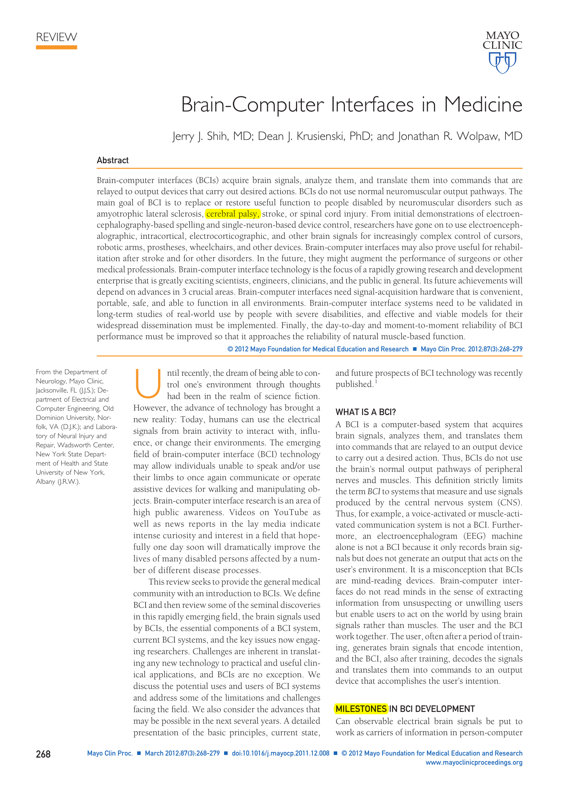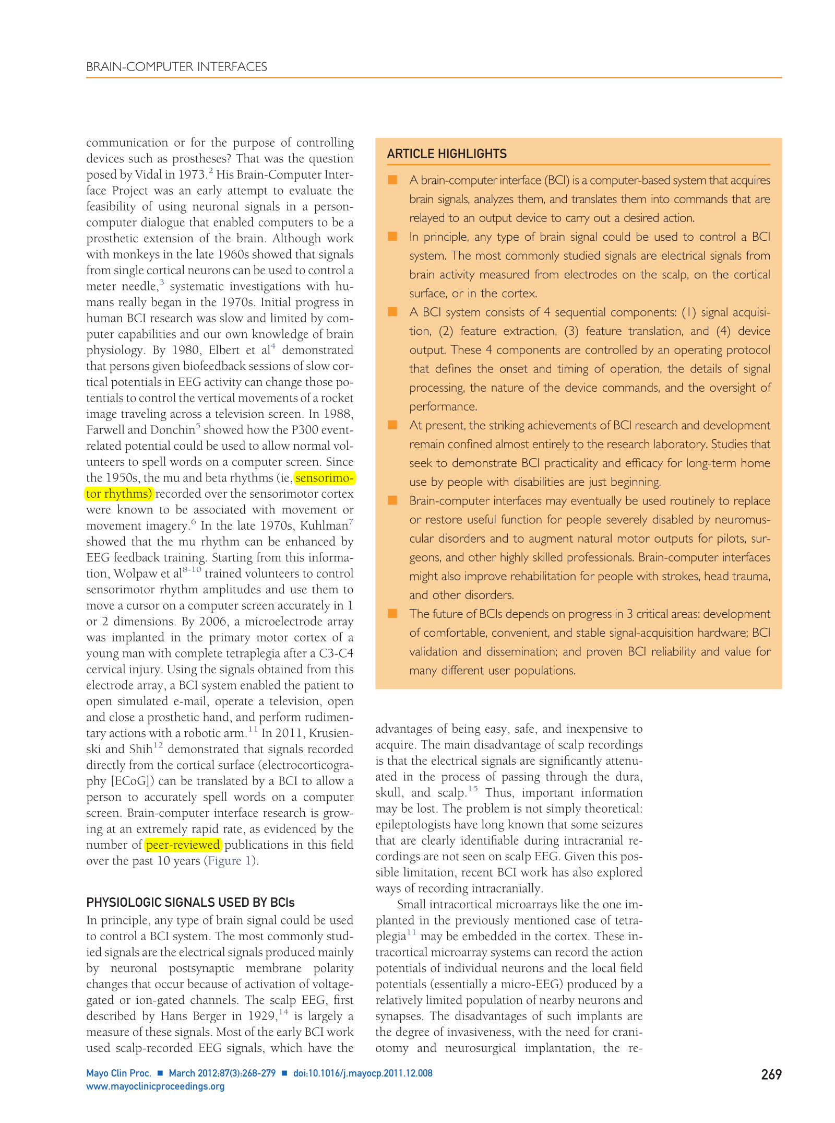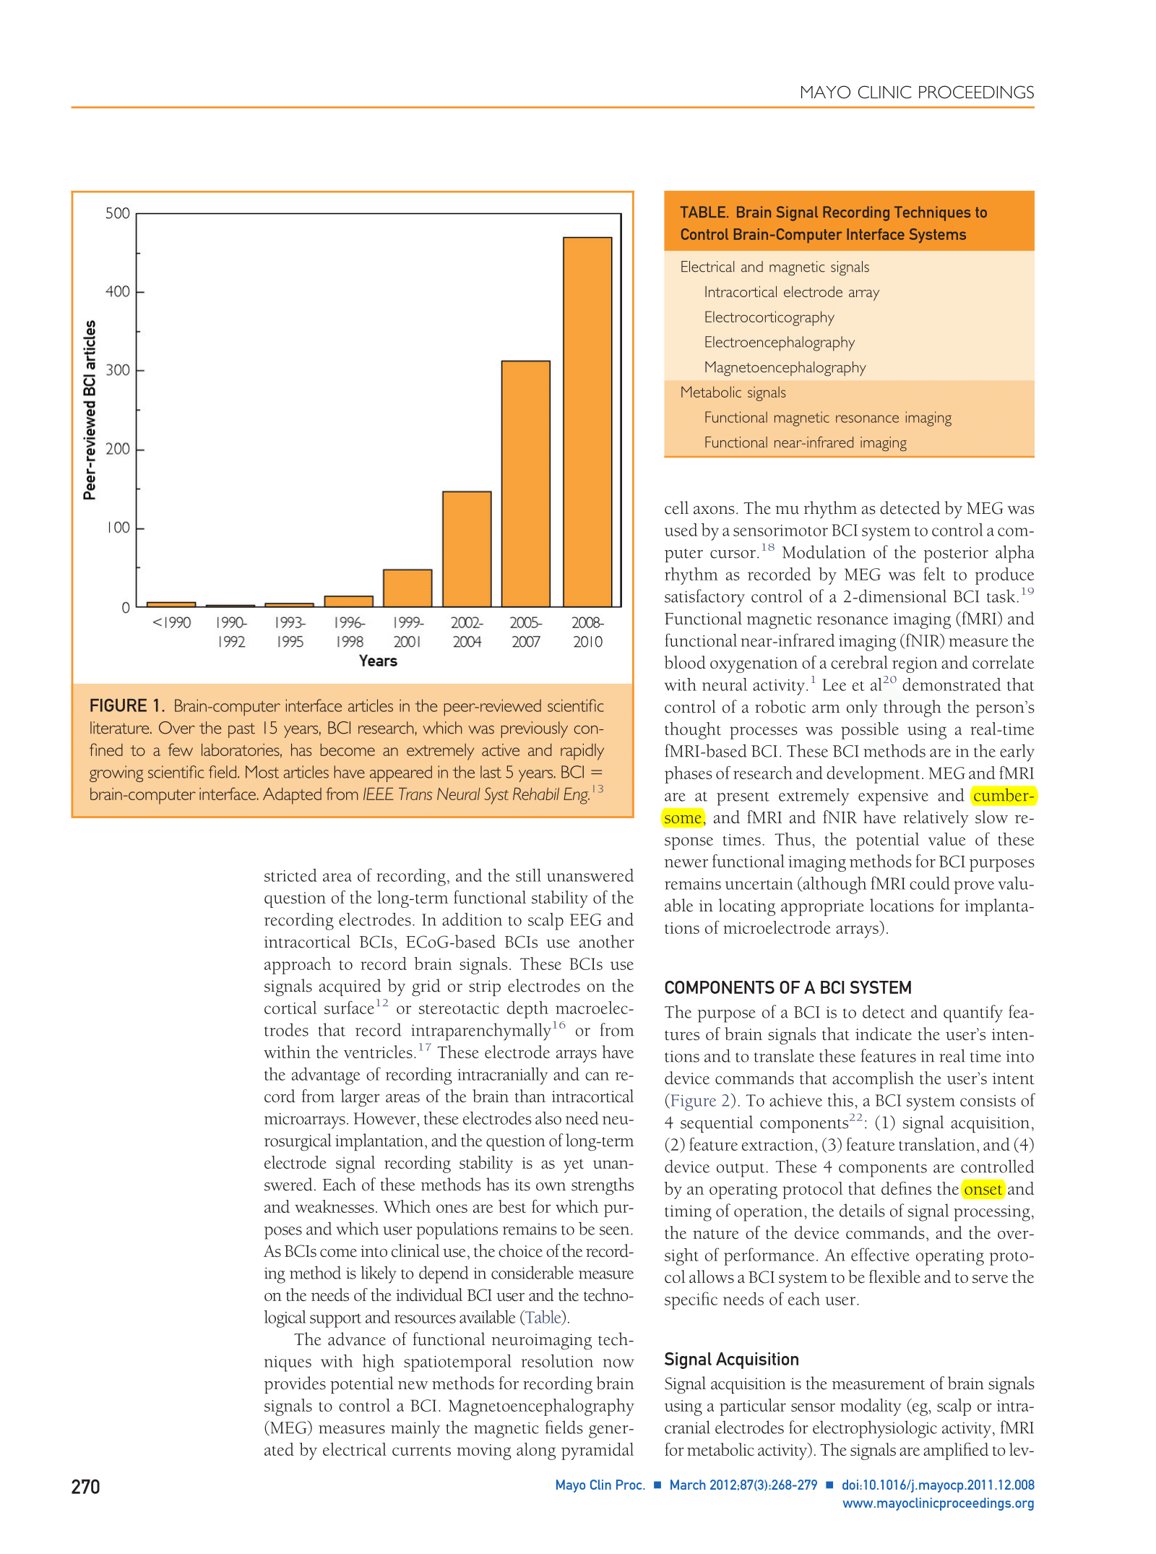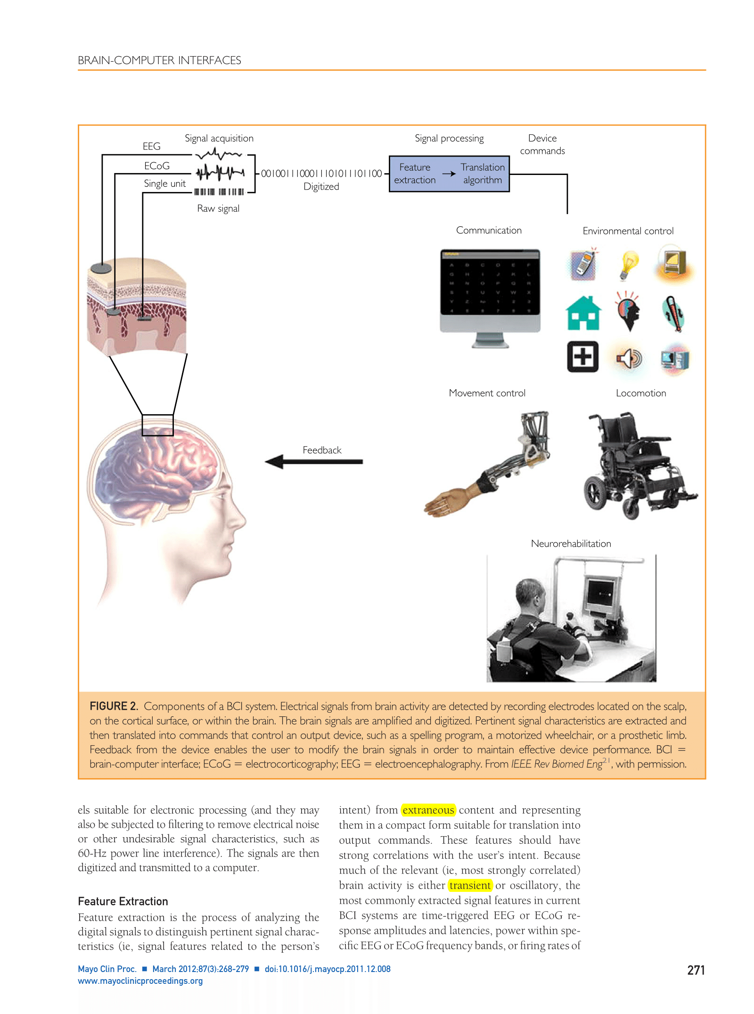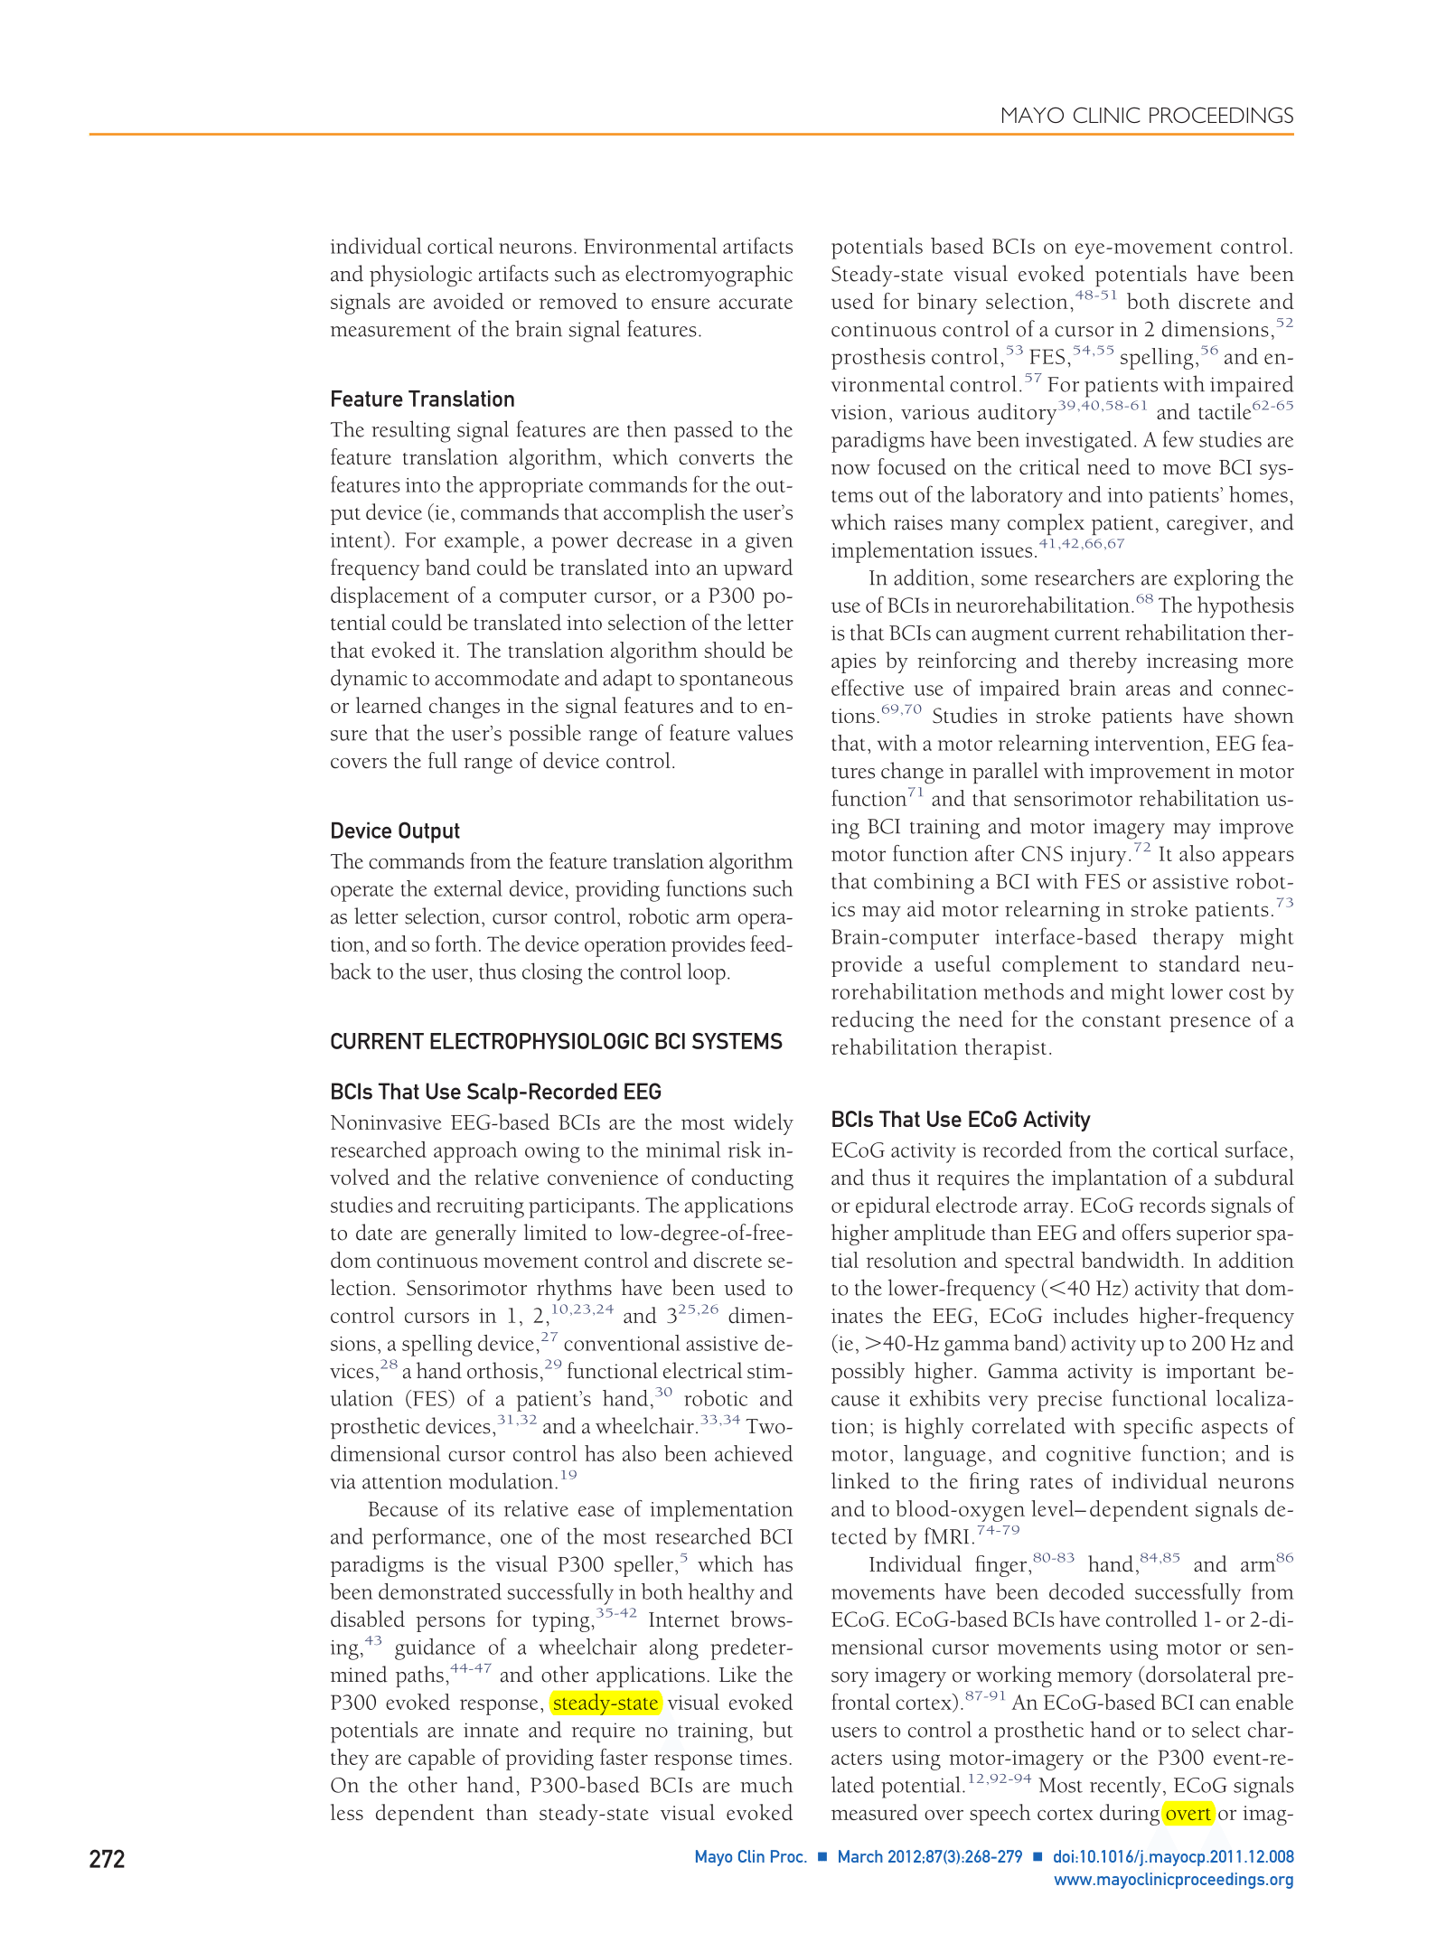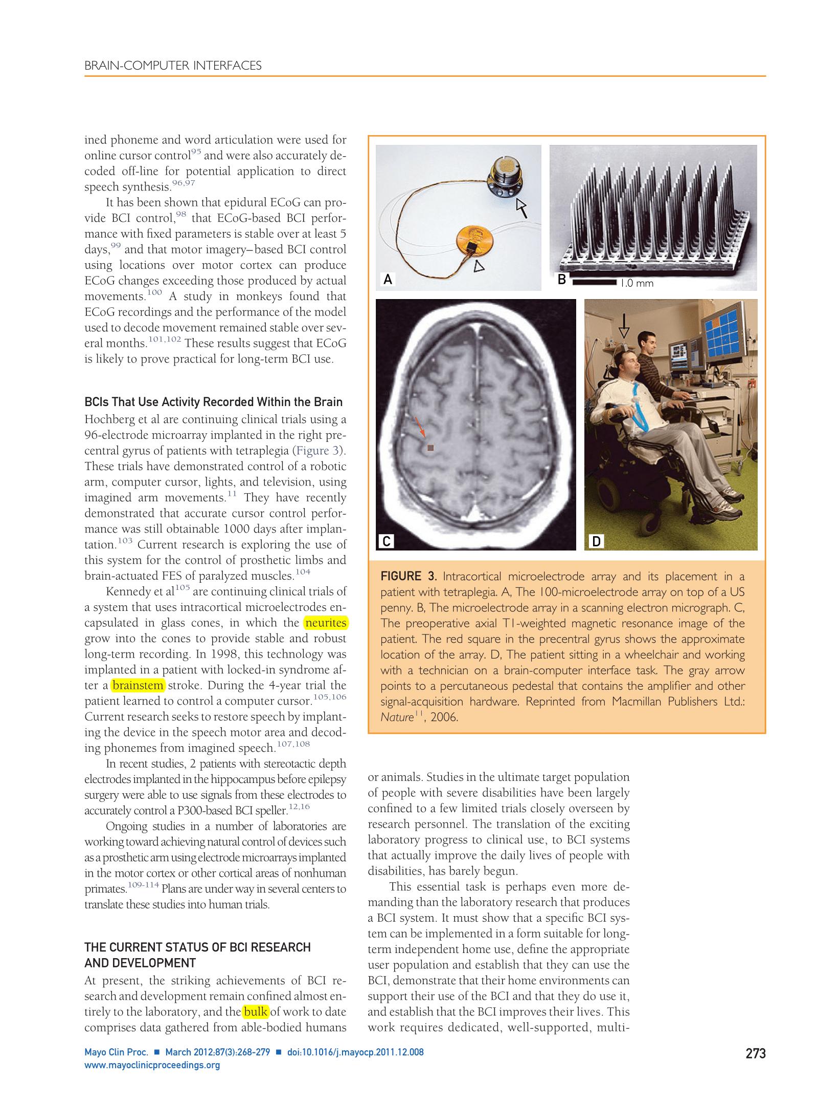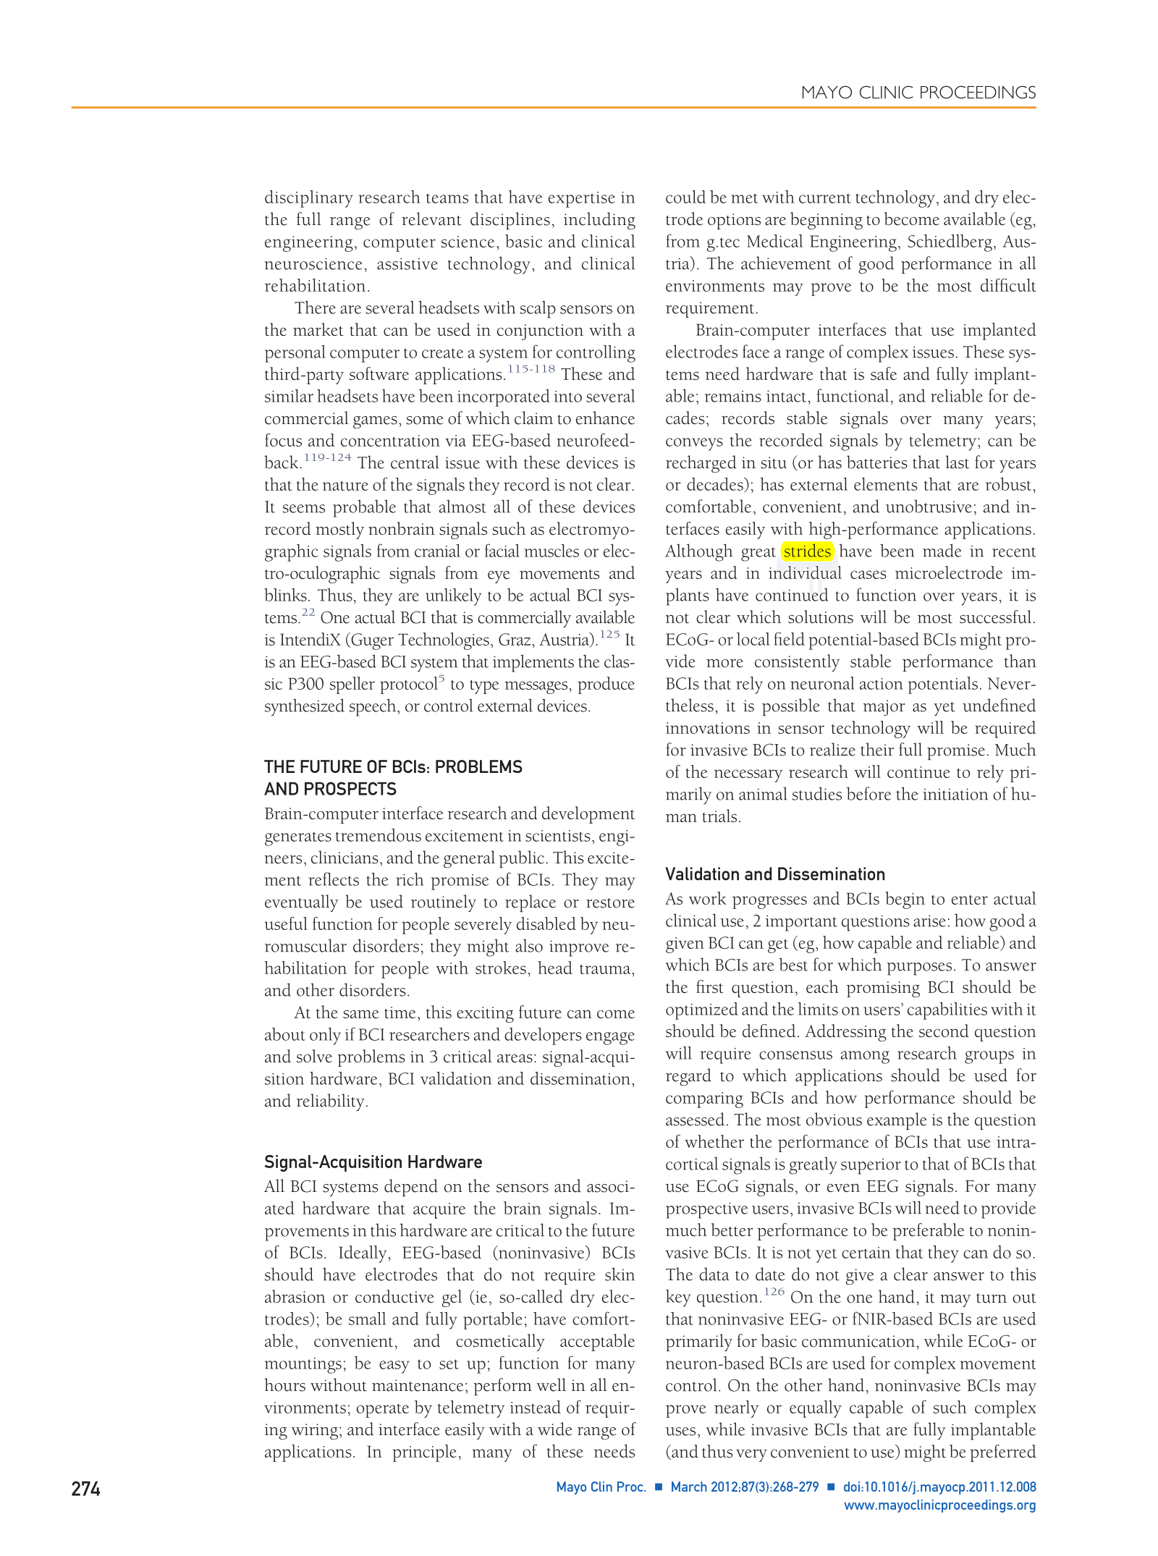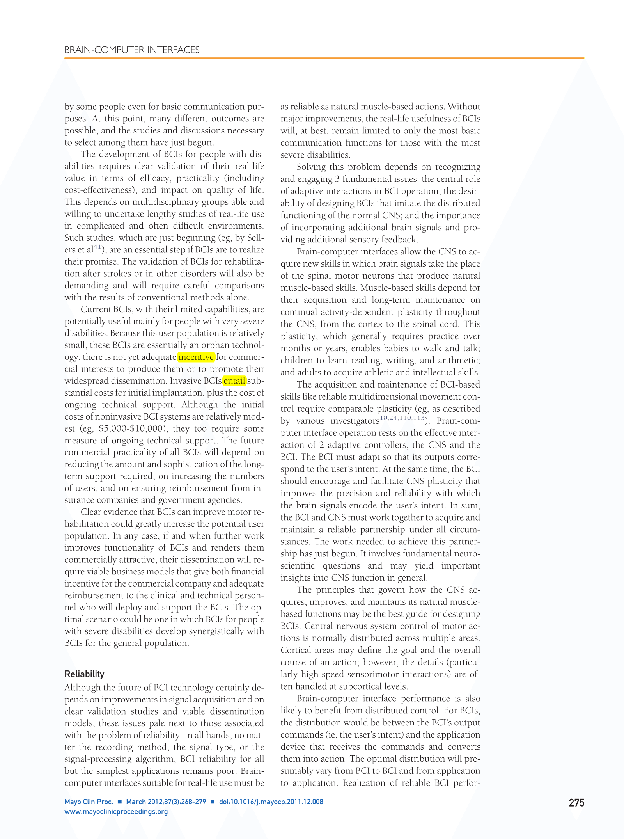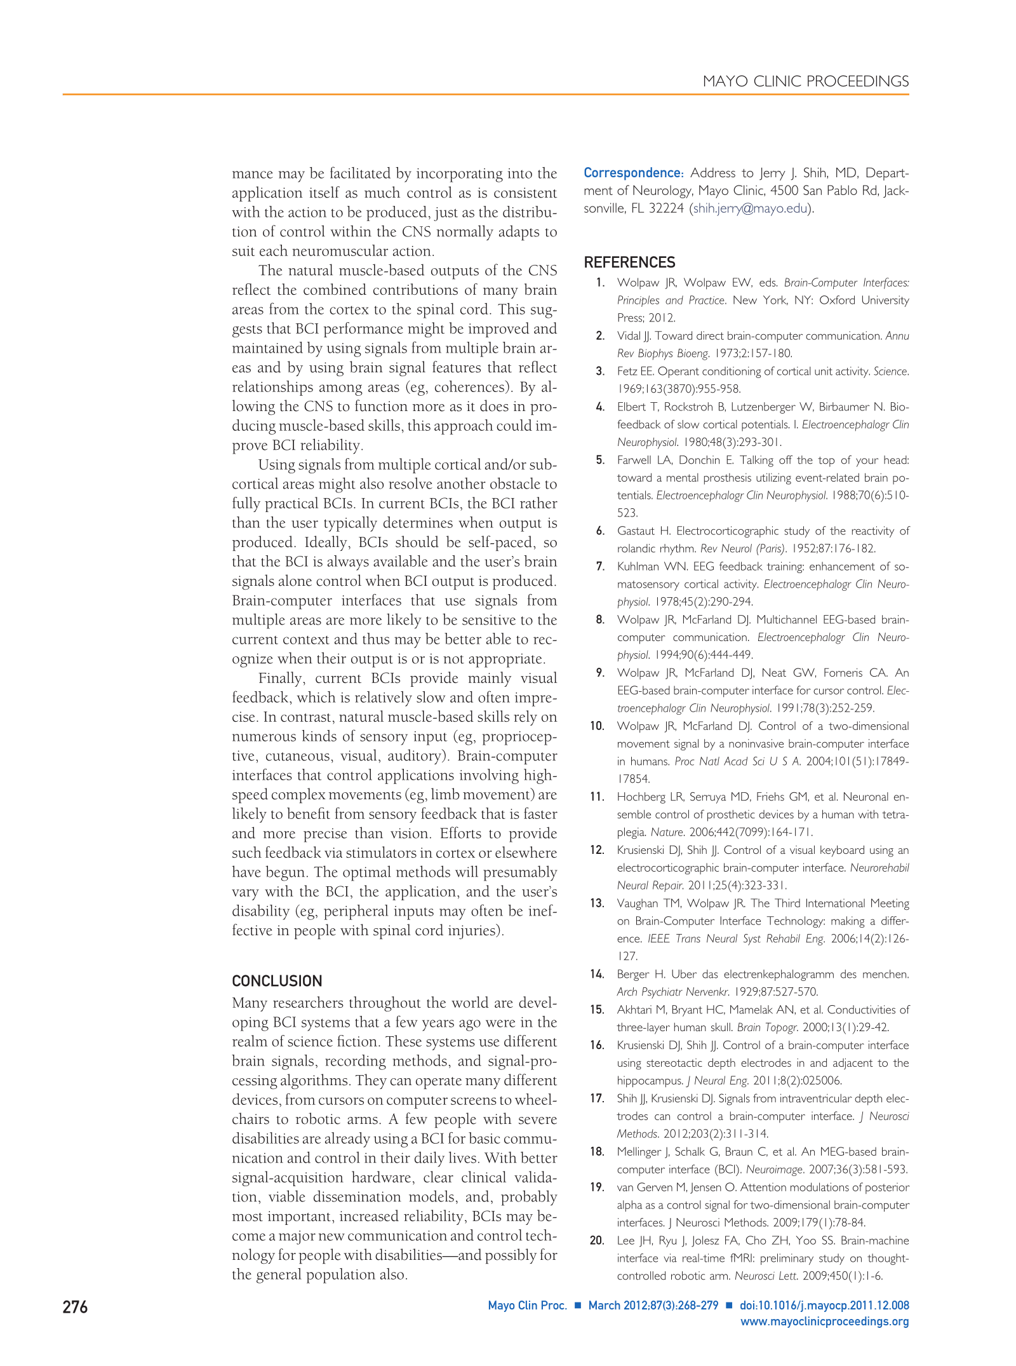

See [**http://www.ncbi.nlm.nih.gov/pmc/articles/PMC3497935/**](http://www.ncbi.nlm.nih.gov/pmc/articles/PMC3497935/)for references.

**Questions**

1. What is the main purpose of the output device used in brain computer interfaces ?
2. What is the role of a computer in a brain computer interface ?
3. When did human investigations with brain computer interfaces begin ?
4. What is the P300 ?
5. In which year did Farwell and Donchin found the way to spell words on a computer screen using the P300 speller ?
6. What kind of signal can we use in a BCI ?
7. What are the pros and cons of a scalp EEG ?
8. What are the pros and cons of small intracortical microarrays ?
9. What are the pros and cons of ECoG-based BCIs ?
10. What are the main problems with MEG and fMRI ?
11. What do we need to consider in order to choose appropriately the signal we want to acquire ?
12. What are the 4 sequential components of a BCI ?
13. What is the controller of these components ?
14. What is the purpose of each component ?
15. Which kind of signal do the P300 speller use ?
16. Which domains of sciences are required in order to move the research from laboratories to patients homes ?
17. Why are headsets with scalp sensors on the market not actual BCIs ?
18. What is IntendiX ?
19. What are the problems that researchers will be confronted to in the future ?
20. What was the syndrome of the patient who got intracortical microelectrodes in glass cones implanted in his brain ?

|  |  |
| --- | --- |
| Review of General Psychology | © 2010 American Psychological Association |
| 2010, Vol. 14, No. 2, 113–121 | 1089-2680/10/$12.00 DOI: 10.1037/a0019441 |

Video Games in Health Care: Closing the Gap

Pamela M. Kato

University Medical Center Utrecht

Although a great deal of media attention has been given to the negative effects of playing video games, relatively less attention has been paid to the positive effects of engaging in this activity. Video games in health care provide ample examples of innovative ways to use existing commercial games for health improvement or surgical training. Tailor-made games help patients be more adherent to treatment regimens and train doctors how to manage patients in different clinical situations. In this review, examples in the scientific literature of commercially available and tailor-made games used for education and training with patients and medical students and doctors are summarized. There is a history of using video games with patients from the early days of gaming in the 1980s, and this has evolved into a focus on making tailor-made games for different disease groups, which have been evaluated in scientific trials more recently. Commercial video games have been of interest regarding their impact on surgical skill. More recently, some basic computer games have been developed and evaluated that train doctors in clinical skills. The studies presented in this article represent a body of work outlining positive effects of playing video games in the area of health care.

*Keywords:* video games, interventions, technology, health

Despite the existence of effective medicines, advanced medical technology, and hospitals staffed by highly trained and educated health care professionals, human beings do not always behave in ways that take advantage of what health care has to offer. A majority of patients do not comply with the treatment regimes that could save their lives (Partridge, Kato, & DeMichele, 2009). Similarly, doctors make mistakes to such an extent that medical errors can be counted among the leading causes of death in the United States (Institute of Medicine, 2001; Kohn, Corrigan, & Donaldson, 1999). The solutions to these problems are clearly complex, yet psychological and behavioral factors play a prominent role. An innovative tool that is being used more and more to address the psychological and behavioral barriers to optimal health care is the video game.

Most people think of video games as entertainment. There is a growing interest, however, in video games as a means to educate and train people (Durkin, 2010). *Serious games* is a term that has been used to describe video games that have been designed specifically for training and education (Annetta, 2010). The field of medicine has a history of embracing games as a means to engage patients behaviorally to improve their health outcomes. There are early reports of case studies using video games with patients experiencing diseases or physical disabilities (Krichevets, Sirot-kina, Yevsevecheva, & Zeldin, 1994; Szer, 1983). We are now seeing more video games evaluated in the literature that are developed and used explicitly for health education and training. Games are now being evaluated in randomized trials with the scientific rigor applied to pharmaceutical therapies (Kato, Cole, Bradlyn, & Pollock, 2008). It is interesting that examples of video game applications in health care consist not only of serious games that are designed specifically training and education purposes, but also of commercially available off-the-shelf games that are repurposed to meet certain behavioral goals in health care.

As deduced from the review that follows, the use of video games to train medical professionals is only in its infancy compared with the depth to which the medium has been explored with patients. This use of games has grown out of the tradition of training physicians with simulations. It has gone from a focus on learning with cadavers and mannequins to the use of computer-generated 3-D interactive software to teach technical skills in medicine. This is the first review to evaluate the state-of-the-art research on video games and their impact on health by evaluating the effect they have had on training medical professionals to provide high-quality health care as well as their impact on patient health.

In this review, psychological theories of play that may explain the effectiveness of games in health care are explored. A history of video games and health is also described, with a focus on studies of video games aimed at improving the health of patients and then on video games that are used to train and educate medical students and doctors. The use of commercial games and tailor-made games for behavioral health or medical training is reviewed. Only games that have been described and evaluated in peer-reviewed publications are presented in this article.

**Theories and Mechanisms**

Video games have been used strategically to affect a number of issues in health among patients. The main mechanism for action often cited is their ability to increase motivation. Engaging a patient’s motivation is frequently necessary in health care because patients are often required to undergo procedures or engage in behaviors that are painful and aversive on the one hand (e.g., undergoing chemotherapy) or boring and mundane on the other (e.g., taking pills, exercising on a regular basis). These procedures and behaviors are often necessary to maintain and improve health or even to cure the patient’s disease. The focus of attention on an engaging distraction is also thought to be a key factor in explaining how individuals manage aversive symptoms through video game play. The repetitive nature of video game play is thought to be a key mechanism that promotes learning in games as well (Rosas et al., 2003).

What seems clear is that these mechanisms are usually activated in games within the context of play. To understand how games can engage and affect patients and doctors, it is important to understand how theorists have conceptualized play.

Play usually has the following attributes: (a) It is usually voluntary; (b) it is intrinsically motivating, that is, it is pleasurable for its own sake and is not dependent on external rewards; (c) it involves some level of active, often physical, engagement; and (d) it is distinct from other behavior by having a make-believe quality (Rieber, 1996, p. 44).

Psychoanalytic theorists viewed play as a means for children to experience catharsis, or a release of tension and fears in a safe context (Freud, 1968). Play is therefore often conceptualized as a means of stress management. Thus, play as stress management probably has a key role in helping patients manage aversive or shameful aspects of their illness through playing video games.

Symbolic interactionist theorists viewed play among children as a means for them to understand their social world (Mead, 1982). Children’s role-playing games (e.g., playing “cops and robbers” or “house”) help them understand different social roles that people have in society. Role playing also helps players develop their sense of empathy, or understanding the feelings and viewpoints of different people. Role playing is clearly a means of play that makes simulations in training medical personnel an appealing way to learn. They can act out dangerous scenarios in a simulated environment so that they can try out their professional roles and make mistakes without fear of real-world consequences.

If we thought about video games as play for adults, we could create a research program that examined the relationship between video game play and social skills such as perspective taking and empathy; psychosocial functioning such as self-confidence, happiness, relaxation, and achievement motivation; and cognitive skills such as attention, planning, spatial reasoning, and creativity. Researchers who develop and evaluate the impact of serious games should acknowledge theories of play as a pathway to learning, not just among children, but among adults as well.

**Reviewed Studies**

**Commercially Available Video Games for Health**

Since the early 1980s, there have been reports in the literature of commercially available video games used for therapeutic purposes in different patient populations (Redd et al., 1987; Szer, 1983). Most of the early reports are directed toward children because the average game player was quite young and video games were largely targeted toward this market. As these gamers grew older, video games became more sophisticated and the market broadened for an older audience (Kent, 2001). This is reflected in the broader age range of the target audiences of video games for health more recently as well.

Below, the use of commercially available video games with patients in a pediatric setting is reviewed. These studies represent some of the earliest reports of the use of commercial games in a therapeutic context with patients in the hospital. Also included is a review of a recent report on the use of a video game application for anxiety management with children.

Next, the history of commercial games used for physical therapy and as exercise is reviewed. It is interesting to note that the earliest applications of video games in health occurred because someone clever made an innovative interface so that the typically sedentary games could be used to motivate patients to engage adolescent and adult patients in physical therapy and physical activity. These innovations are needed less and less as modern commercial games and console systems now have innovative hardware interfaces that require the user to be physically active. The application of these games to health is described as well.

**Nausea in pediatric cancer.** Commercially available videogames have been shown to have therapeutic effects on side effects associated with the treatment of cancer. These side effects include nausea, vomiting, anxiety, and pain associated with chemotherapy or radiation treatments. The therapeutic effects of games are attributed to the distraction that games provide that focus attention away from these aversive side effects. In an early report of two experiments (Redd et al., 1987), young patients (age range 11–20 years in Experiment 1; age range 9 –18 years in Experiment 2) in pediatric oncology who played a video game for 10 min during chemotherapy induction showed significant decreases in reported nausea compared with control patients. Children assigned to the video game group could choose from 25 different games on an Atari 800 XL computer system. Children in the control group were allowed to play with nondigital books, toys, games, or TV. These results suggest that there is something more engaging and distracting involved in video game play than with nondigital play objects or entertainment.

A similar study (Vasterling, Jenkins, Tope, & Burish, 1993) compared patient groups provided cognitive distraction through video games or standard relaxation training with a control group of young cancer patients. The patients in the video game distraction group and the patients in the relaxation-training group reported less nausea prior to chemotherapy and had lower blood pressure following chemotherapy compared with controls. There were no differences between the distraction and relaxation-training patients, indicating that the treatments were similar in effectiveness. Practically speaking, however, relaxation training requires a trained therapist to administer. The cost, time, and availability of trained professionals make it difficult for many hospitals to take advantage of this technique. In contrast, computer games are less expensive over time, readily available, and considered acceptable therapies by the patients, making them ideal for interventions for conditioned nausea in young patients with cancer.

**Anxiety management.** The previous studies demonstratingthe effective use of video games as distractors for nausea management are classic examples of the early work of using commercially available games as therapy that capitalize on the ability of games to distract patients’ attention from aversive symptoms. The study presented below examined the use of commercial games as distractors to help young patients manage their anxiety in a hospital setting. This recent work explored the use of a portable game platform on which the games can be played, which may improve the ease of use and accessibility of this type of adjunct to therapy.

In a study of 112 children (ages 4 –12 years) undergoing general anesthesia for elective surgery, patients were assigned to one of three groups: (a) parent present, (b) parent present oral midazolam (preop sedative), or (c) parent present a hand-held video game distraction (Patel et al., 2006). The video game distraction consisted of 10 commercial games to play on a Nintendo Gameboy platform (A. Patel, personal communication, November 4, 2009). Patients who did not have a hand-held video game showed significant increases in anxiety from baseline to induction of anesthesia. Patients who played the video games showed no significant increases in anxiety from baseline to induction and reduced anxiety compared with the parent-present group and no difference with the midazolam group during induction of anesthesia. These findings are significant for this population group and procedure because the games and hand-held device represent a low-cost, easy-to-implement, portable, and effective method of anxiety management in a vulnerable population during a critical time of care. Furthermore, the findings have clinical implications because the impact of the video games on anxiety was as effective as a pharmacological intervention for anxiety. Future studies should explore the use of this game platform for anxiety management with young patients in other stressful situations in the hospital (e.g., chemotherapy induction, venipuncture).

**Physical therapy and physical fitness.** There are early re-ports in the literature that the mere physical requirements of playing a regular video game (e.g., joystick control, arm reaching) can have therapeutic effects as physical therapy for arm injury (Szer, 1983), Erb’s palsy (Krichevets et al., 1994), and traumatic brain injury (Sietsema, Nelson, Mulder, Mervau-Scheidel, & White, 1993). The success of video games as an adjunct to physical therapy can be attributed in large part to the increased engagement and motivation that video games add to typically mundane and repetitive tasks associated with physical therapy. In other words, patients may cooperate more fully with the procedures required in physical therapy when the procedures are combined with or are part of an entertaining game.

Racing games have been used in combination with physical exercise equipment for physical therapy for different patient groups. For example, in one study, racing games were used with manual wheelchair interface called GameWheels with 35 patients with spinal cord injury (O’Connor et al., 2000). The interface turned the wheelchair into a virtual joystick in which users could control game play through the movement of their wheelchairs wheels on the rollers of the interface. Players were motivated to maneuver their wheelchairs on the device in order to play popular racing games (e.g., *Need for Speed II* and *Power Boat Racer*). The results showed that patients using these devices were able to reach fitness goals as indicated by results of a submaximal oxygen consumption test (VO2/kg) and heart rate monitoring. Unfortunately, this study did not include a control group of patients who were asked to engage in the activity with the device without a video game interface. This would have helped to more precisely define the causal effects of the video game in achieving the observed results.

In a more recent study, a commercially available video game *Need for Speed* was used in conjunction with an add-on exercisehand crank device (ergometer) called the GameCycle to control movements in the games (Widman, McDonald, & Abresch, 2006). Patients were adolescents with spina bifida, a congenital malfor-mation of the spinal cord. These patients had mobility impairments associated with their disease that did not allow them to participate in most mainstream sports. The game intervention focused on an area of physical activity for the patient population that they could engage in and combined it with the video game play to improve their motivation to engage in physical activity. The 4-month home-based video game– exercise intervention showed that most patients were able to reach levels of intensity training consistent with guidelines set forth by the American College of Sports Medicine for the general population (i.e., at least 50% of VO2 reserve or 50% of heart rate reserve). Patients in the study who did not meet this standard had the highest baseline strength values and reported that the intervention was not physically challenging. Closer inspection of this group revealed that these patients were already physically fit. This suggests that the intervention was effective for patients who needed it the most. Subjective ratings of the intervention also revealed that virtually all patients found exercising on the Game-Cycle to be easy, enjoyable, and physically challenging. A similar study comparing a standard ergometer with the GameCycle (ergometer combined with a video game) found that wheelchair athletes who exercised with the GameCycle and accompanying video games showed increased intensity of training compared with controls (Fitzgerald & Cooper, 2004). An interesting finding was that each group’s reported perceptions of exertion levels did not differ.

The studies above demonstrate that video games have the potential to positively influence physical activity in populations of medical patients, especially those with physical impairments. In recent years, a new generation of commercial games has been developed that explicitly requires mainstream audience of users to be physically active as part of game play. Although studies have linked video game play with obesity (Vandewater, Shim, & Caplo-vitz, 2004), video games that accompany wireless video game console systems (e.g., the Nintendo Wii) and certain accessories (e.g., the dance pad with *Dance Dance Revolution*) have been shown to significantly increase energy expenditure among players (Graves, Stratton, Ridgers, & Cable, 2008; Lanningham-Foster et al., 2006). Although the energy expenditure may not be as great as engaging in an authentic version of the sports simulated in the games (e.g., boxing, tennis, and bowling), these video games provide alternative activities for individuals concerned about video games as a sedentary activity. In fact, these games are among the most popular video games on the market. The Nintendo Wii *Fit* game, in which players engage in strength, balance, and aerobic activities, has topped the charts as the best-selling console game (Orry, 2009). *Dance Dance Revolution* was a chart-topper as well (Konami Digital Entertainment—America, 2005).

The use of commercially available video games to increase physical activity challenges a prevailing assumption that playing video games is a sedentary activity. The positive effects of these games stand in contrast to concerns that excessive gaming is related to negative outcomes such as repetitive stress injuries (Mirman & Bonian, 1992). In most of these studies, specialists supervised the therapeutic use of the games. In addition, the patients were probably engaged in the games in a way that was representative of average players of games who do not play in excess to the point of physical injury.

**Tailor-Made Games for Health**

As the general popularity of video games grew and it was clear that video games could be used to engage patients in their care, video games were made specifically to address issues in health care. These games built on past research that showed that video games were effective as a distraction for pain, nausea, and anxiety. They also built on past research evidence that video games were powerful motivators for people to engage in active behaviors. Whereas commercial games were used to increase compliance in physical therapy, the new tailor-made games were used to increase compliance with other treatment directives by delivering health-related information, modeling positive health behaviors, and providing opportunities for players to vicariously practice engaging in positive health behaviors for specific patient groups.

**Burn pain.** Building on the power of commercial video gamesto distract patients and provide a means of pain management, a team of researchers and game designers developed a virtual reality game for burn patients called *SnowWorld*. In this game, players are immersed in a virtual reality world where they fly through an icy landscape of a canyon, cold river, and waterfall through gently falling snow. As they navigate their way through the canyon, they can shoot snowballs at snowmen, penguins, igloos, and robots. In contrast to games used for physical therapy and exercise, this game was designed specifically to minimize body motion during gameplay to enable wound care (debridement) by nurses (Hoffman et al., 2008). This was possible because players controlled their movements and activities in the game (such as throwing snow-balls) by manipulating a fixed joystick. Studies of this intervention showed that it was effective in reducing pain perception among 11 burn patients in a pretest–posttest evaluation (Hoffman et al., 2008). One randomized controlled trial of the virtual reality intervention showed a 20% reduction in subjective reports of pain when compared with standard analgesic interventions (Sharar et al., 2007). Although it is not clear from the design of the evaluative studies of the game if the “cool” (temperature-wise) imagery of the game induced an extra level of pain tolerance, it does seem clear patients who felt themselves “present” in the cool world of the game reported feeling less pain. Furthermore, it was surmised that the increased reports of the virtual reality intervention as being “fun” also contributed to greater compliance with the painful procedures involved with treating burns such as burn debridement. Finally, the results of this work suggest that virtually immersive games may also have therapeutic effects in other patient populations with pain management needs.

**Diabetes.** One classic video game for health is*Packy and**Marlon*, which was originally made for the Super Nintendo gameconsole system. The game is aimed at children with diabetes. The characters in the game are two elephants that are at a diabetes summer camp. They have to get rid of a gang of marauding rats that are keeping the campers from healthy food and diabetic supplies. To win, players have to successfully manage their insulin levels and food intake while keeping their characters’ glucose levels within an acceptable range. This game was evaluated in a randomized trial in which participants in the treatment group played the game for 6 months (Brown et al., 1997). By the end of the study, patients who had access to the game showed greater perceived self-efficacy for diabetes self-management, increased communication with parents about diabetes, and improved dailydiabetes self-management behaviors (e.g., monitoring blood glucose levels regularly, taking insulin as needed, eating the right foods). More impressive, in terms of objective health outcomes, the treatment group had a 77% decrease in diabetes-related emergency and urgent care clinical visits compared with controls. These findings have clinical significance because they show that an interactive video game can have an effect on important health behaviors in children with a chronic illness.

**Asthma.** *Bronkie the Bronchiasaurus*is a video game on theSuper Nintendo Entertainment System platform that was made for young children with asthma. The game is set in prehistoric times and the world is covered in dust. A fan that usually keeps the dust at bay has broken. Players help the two in-game characters, Bronkie and Trakie, keep their asthma at bay by avoiding triggers such as dust and smoke while they go on their quest. There are some textual question-and-answer inserts in the game along the way that need to be answered correctly in order to proceed. A series of studies on the game found that patients’ asthma-related self-concepts, social support, knowledge, self-care behaviors, and self-efficacy improved after playing the game compared with a control group (Lieberman, 2001). These findings contribute to our knowledge about what video games can do to affect important health beliefs and practices among young children.

The interactive game *SpiroGame* was developed for use with a device that measures and gives a readout of breathing function for spirometry. Spirometry is a measure of lung function, and it is used with patients who have diseases associated with compromised lung functioning such as asthma or cystic fibrosis. Spirometry is often difficult to perform with young children because it depends highly on patient cooperation and effort during the procedure; however, spirometry conducted with the measuring device paired with the *SpiroGame* was shown to promote the successful measurement oflung functioning in preschool children (Vilozni, Barker, Jellous-chek, Heimann, & Blau, 2001). The game teaches 3- to 6-year-old children to differentiate between inhalation and exhalation and to control their breathing. Children controlled an animated caterpillar through their breathing. The caterpillar crawls to an apple over a period of 30 s as long as the child’s breathing reaches targets predetermined by a computer algorithm. Another minigame teaches children how to do a breathing test by pairing attainment of certain breathing targets with the movement of an animated bee flying from flower to flower. These games are good examples of how interactive technology can be used not only to motivate behaviors, but also to train and to obtain higher than expected performance of target behaviors from a group of very young children.

**Bladder and bowel dysfunction.** Video games, in particularthose that employ biofeedback to control gameplay, have been used successfully to treat patients with pediatric voiding dysfunction or irritable bowel syndrome (IBS).

Pediatric voiding dysfunction is diagnosed in children who do not empty their bladder normally and experience bedwetting and daywetting. Treatments include pharmacological interventions along with behavioral treatments that include dietary management, a timed voiding schedule, and muscle training of pelvic floor muscle groups that are involved in urinary continence. Biofeedback, an effective treatment modality to train the pelvic floor muscles among these patients (Pfister, Dacher, & Gaucher, 1999), is often a part of treatment. Similar to other interventions that involve behavior change, the success of biofeedback depends on patient motivation and compliance with the program. Children are generally not interested in dealing with the embarrassing topic of incontinence, and they also have difficulty remaining focused on the task of biofeedback training. Biofeedback combined with a game interface was used to increase interest and motivation to engage the therapy. In this method, sensors are placed by a nurse on the child’s perineum to detect pelvic floor muscle activity. Leads from the sensors connect to a port on the computer in which electrical activity from the sensors is transformed through algorithms to relate to actions in the game. The games used to treat pediatric voiding dysfunction were PC-based games of golf, space-ships, baseball, basketball, and a safari adventure. For example, in the golf game used in this study, pelvic floor contractions determined the distance a golf ball traveled. In the basketball game, accuracy of shooting a basketball through a hoop was related to the patient’s ability to relax the pelvic floor muscles. Studies of these biofeedback games showed improvements in symptoms and high levels of treatment compliance through self-report and objective measures (Herndon, Decambre, & McKenna, 2001; McKenna, Herndon, Connery, & Ferrer, 1999). In addition, the biofeedback computer game program proved to be useful in children with pediatric voiding dysfunction as young as 4 years old (Herndon et al., 2001), a group previously thought to be too young for biofeedback muscle training because of limited ability to cooperate and motivation to engage in it (De Paepe et al., 2000).

A computer biofeedback game was also designed for patients with IBS, a gastrointestinal disorder characterized by abdominal pain, bloating, constipation, and diarrhea. Symptoms are controlled through medication and behavior management such as diet and stress management techniques. A biofeedback game that was developed for patients with IBS was designed to teach stress management through deep relaxation exercises (Leahy, Clayman, Mason, Lloyd, & Epstein, 1998). Biofeedback sensors connected to the patients’ fingers measured electrodermal activity, or micro-changes in the skin’s sweat response. The patient was able to control the animated representation of bowel movement through changes in their electrodermal conductivity that the biofeedback sensors detected when the patient engaged in mental and physical relaxation techniques. The patients were able to control their movement in an animation of the gut (intestines) to the extent that they were able to relax. A study of 40 patients with IBS who were refractory to conventional treatment showed that four half-hour biofeedback sessions resulted in reports among half of the patients that the technique helped them control their symptoms. Patients also showed significant reductions in global and bowel-specific symptom scores. In long-term follow-up of the patients, 64% of the patients reported that they continued to use the techniques they had learned. The advantage of using this biofeedback game to teach stress management over interpersonal therapy is that it does not require the assistance and guidance of trained therapists because it can be self-administered. The game was probably also motivating and useful for this group because it allowed the users to deal with managing embarrassing aspects of their disease in a private manner.

**Pediatric cancer.** *Re-Mission*is a game made for adolescentsand young adults with cancer. The goal of the game is to improve treatment in this often “hard-to-reach” age group of patients. In the game, players control a nanobot named Roxxi. Roxxi flies through the body of different cancer patients to destroy cancer cells and tumors with chemotherapy and radiation. She also combats side effects of treatment such as pain, nausea, infection, and constipation. Information is provided visually through animations and direct interactions with environments. In a randomized trial (Kato et al., 2008) with 374 patients between the ages of 12 and 29 at 34 medical centers in the United States, Canada, and Australia, patients who played *Re-Mission* were compared with patients who played a control game, *Indiana Jones and the Emperor’s Tomb*. Patients who played *Re-Mission* over the 3 months of the study maintained higher levels of chemotherapy in their blood and took their prophylactic antibiotic medication more frequently as prescribed than patients in the control group. Patients who played *Re-Mission* also showed greater increases in knowledge aboutcancer and self-efficacy to manage their cancer than patients in the control group. The research showed that a tailor-made video game for young people with cancer can have an impact on important health behaviors that are related to survival outcomes.

The evidence supports the use of tailor-made games for specific medical goals. These games vary widely in terms of their content and the platforms on which they are delivered, yet they all harness the power to focus, engage, and motivate players in an activity. They go beyond the strengths of commercial games in their ability to increase specific knowledge about self-care and disease. They are also useful because they can help patients manage embarrassing aspects of certain illnesses in a private way. They can help patients develop specific skills needed to manage illnesses in a cost-effective, easily distributed way. In addition, even though video game reviewers may find that these games for health do not meet their standards for graphics and gameplay (Atriou, 2009; Stahl, 2009), their intended users give them high ratings of acceptability and find them engaging (Kato & Beale, 2006; Lieberman, 1997).

**Commercially Available Video Games in**

**Medical Education**

Video games and video game technology have long been used to improve patient safety and patient care through their use as tools to teach doctors. Commercial games have been explored as a means to improve surgical skills, and tailor-made games for medical students have been used to teach clinical skills. Research on these games is reviewed below.

**Surgical skills.** The relationship between video game play andsurgical skills has been a focus of attention in particular because skills in playing certain video games are also crucial in performing surgery (e.g., visual spatial performance, eye– hand coordination, fine motor control, and reaction time). Studies have focused on how video game play may enhance some of these skills in a normal population. There is evidence that individuals who are avid video game players show enhanced visual attention skills (Green & Bavelier, 2003) and visual memory (Ferguson, Cruz, & Rueda, 2008). There is also causal evidence that nonplayers trained on video games show improved visual skills (Green & Bavelier, 2003, 2007). Other research has shown, however, that avid video game players do not differ from nonplayers in their visual processing strategies but merely have faster response times to visual attention tasks (Castel, Pratt, & Drummond, 2005).

Studies with physicians that have examined the relationship of video game play to actual surgical skills such as targeting and grasping objects and suturing have also shown a great deal of evidence of a positive association. One study that compared the surgical skills of avid video game players ( 3 hr/week) with their less avid counterparts found that the avid players made 37% fewer errors and were 27% faster in completing a simulated laparoscopic procedure and suturing (Rosser et al., 2007). Physicians in this study were also asked to play three video games in the lab: *Super* *Monkey Ball 2*, *Star Wars Racer Revenge*, and *Silent Scope*. Thephysicians’ skill in playing these video games and their past experience playing games explained a significant amount of variance in their performance on the simulated laparoscopic procedure. A number of similar studies have been carried out that also show that physicians who play video games or are skilful at playing games make fewer errors in performing laparoscopy (Grantcharov, Bardram, Funch-Jensen, & Rosenberg, 2003), are faster at achieving proficiency on certain tasks in a laparoscopic simulator (Shane, Pettitt, Morgenthal, & Smith, 2008), and are more efficient in screening and faster in examining during simulated gastroscopy (Enochsson et al., 2004).

One study with mixed findings showed that medical students with previous video game experience had enhanced skills in maneuvering safely in a sinus surgery simulator. Their advantage, however, did not hold as the demands and realism of the sinus surgery simulator increased at higher levels (Glaser, Hall, Uribe, & Fried, 2005). There are also studies that did not find an association between video gameplay experience or skills and robotic surgical performance (Hagen, Wagner, Inan, & Morel, 2009; Harper et al., 2007) or endoscopy (Westman et al., 2006).

Taken together, the above studies are compelling, yet they merely show a correlation between video game experience or skill and surgical skills. They do not demonstrate the causal relationship that playing games will lead one to be more skillful in surgery. A handful of studies have more recently tested this causal claim. One study that found that video game skills were indeed associated with laparoscopic skill among novice surgeons also examined more closely the causal role of playing games on laparoscopic surgery skills (Rosenberg, Landsittel, & Averch, 2005). In this small study, participants were randomly assigned to a control group or a gaming group. The control group (*n* 6) was asked to refrain from playing any video games for 2 weeks and the game group (*n* 5) was asked to play any type of video game for 2 weeks. At the end of this time period, members of both the treatment and control groups returned to the lab for assessment of their laparoscopic skills. Surgeons in the gaming group played games for 6.2 hr on average during the 2 weeks and surgeons in the control group reported that they did not play any games. No difference was found in laparoscopic skills between these two groups at follow-up; however, this was not surprising given the small sample size, the low level of intensity of the gaming intervention, and the lack of control over the types of video games played.

More recently, another study examined the causal effect of playing games on virtual surgical endoscopy skills with a relatively more scientifically rigorous research design. In this study (Schlickum, Hedman, Enochsson, Kjellin, & Felländer-Tsai, 2009), medical students were randomly assigned to one of three groups. For a total of 5 weeks, one group of participants (*n* 15) underwent systematic training with the video game *Half-Life*, a 3-D first-person shooter game; another group underwent training with a 2-D non–first-person shooter game called *Chessmaster*. These two groups were asked to play between 30 and 60 min a day, 5 days a week, for 5 weeks. The control group participants were asked to refrain from playing any video games at all for 5 weeks. At follow-up, both video game training groups showed significant improvements on the MIST-VR simulator, whereas those in the control group showed none at all. Only the *Half-Life* group showed improvements on another surgical endoscopy task on the GI Mentor simulator. The enhanced skills shown by the *Half-Life* group were thought to be due to the high visual spatialskill demands of this game and its visual similarity to endoscopy. This suggests that the content and demands of video games are important for a transfer to surgical skills to occur. Overall, this study is the most scientifically sound study to date that provides evidence that playing certain video games can improve surgical skills.

In sum, the research suggests that playing video games certainly does not make surgical skills worse. In some cases, it has no effect at all but, overall, both the correlational studies and the more scientifically grounded controlled study suggest that playing certain video games do improve surgical skill.

**Tailor-Made Games in Medical Education**

There are surprisingly few reports in the literature of tailor-made video games used to teach clinical skills. There are even fewer reports of evaluations of these games. In addition, it is often up for debate whether or not the software used in these areas is actually a video game or merely taking advantage of video game technology such as 3-D modeling software and game software engines in simulation scenarios.

**Cancer care.** The*Oncology Game*was developed for medicalstudents to help them appreciate the multidisciplinary aspects of oncology patient management, increase their knowledge of general principles in cancer care, and promote teamwork skills in solving clinical problems. The PC-based game was designed so that two teams of two students played the game at a time. Sixteen patient scenarios were developed for the game. Treatment plans for the patients required the involvement of two or three of the following cancer specialties: medical oncology, radiation oncology, and surgical oncology. At the start of the game, each student on a team is randomly assigned two patients. Teams work together to advance their patients through the game through surgery and medical and radiation oncology clinics in the best order to obtain the best treatment. Players are presented with questions on general oncology along the way. If they give a correct answer, they can proceed to the next clinic automatically. If they are incorrect, they must rely on the roll of the die to proceed to the clinic. The goal of the game is for each team to complete the treatment of four patients in order. A study was conducted to evaluate the effect of the game on medical student knowledge and their appreciation of the multidisciplinary nature of cancer management (Fukuchi, Offutt, Sacks, & Mann, 2000). Pre- and posttest evaluation of 16 students who played the game over a 3-week period showed that students who played two or more rounds of the game answered significantly more questions correctly on a 16-item true–false questionnaire about 16 different types of cancers represented in the game.Students gave highly favorable subjective ratings of improvements in their understanding of principles in cancer treatment, their knowledge of cancer, and their appreciation of the multidisciplinary nature of cancer through playing the game.

**Breast health.** The same group that developed the interactive,computer-assisted board game for cancer above (the *Oncology* *Game*) also created a similar game that simulated the outpatientevaluation and management of patients presenting with breast problems. In this game, each player is responsible for managing four in-game patients. Patients are introduced when players roll a virtual die and drag the patient icon to a specified location so that the patient chart can be reviewed. A history of the patient is provided, and the player can advance the patient across the board to a number of locations for a mammography, ultrasound, or other procedure (biopsy, fine needle aspiration, etc.). Players may continue until they feel prepared to make a management decision. They have a choice of five decisions to make. If they make the correct decision, the patient is considered successfully managed and removed from the board. If they make an incorrect decision, they lose a turn. The goal of the game is to be the first to successfully manage all four patients. The 33 students who played the game showed significant improvement from pre- to posttest on a 10-item true–false test on breast problem management. They also gave the game favorable ratings for usefulness and appeal (Mann et al., 2002).

The *Oncology Game* and the game for breast health may be quite simple in their approach and design, but they are remarkable in medical education because they openly combine play with learning. The findings are intriguing and promising, but controlled outcomes studies are needed to more fully determine the causal role that this approach to educating doctors has on learning and ultimately on clinical practice.

**Simulations.** There are reports of other games to teach clinicalskills in the literature, but they are only descriptive reports of these games. They are mentioned here because they show strong promise and potential for affecting health outcomes. Both of these games are simulation-based, and it is unclear from their descriptions what, if any, game mechanics they use to engage the player in the scenarios depicted.

*Burn Center* is a training module simulation that teaches triageand resuscitation in a simulated mass casualty disaster scenario with 40 patients (Kurenov, Cance, Noel, & Mozingo, 2009). *Pulse!!* is simulation software that replicates the National NavalMedical Center at Bethesda, Maryland. It is aimed at both civilian and military medical students and professionals. A report in the medical literature says that it offers an “epistemic framework for optimizing cognitive and psychomotor skills in clinical practices” (Johnston & Whatley, 2006, p. 240). Despite the apparent sophistication of these games and their aims, no evaluation of the efficacy of these tools to affect clinical practice exists in the literature. Evaluating the efficacy of games such as *Burn Center* and *Pulse!!* presents a rich opportunity for future research, and the findings will further our knowledge about what video games can do to improve clinical skills.

**Discussion**

The research evaluated and reviewed here demonstrates that video games can positively affect health behaviors and outcomes. The use of commercial and tailor-made games to improve the health of patients shows that a great deal of innovation and creativity has gone into making this medium work in effective ways for patients. On the other hand, the use of games for medical education is just in its infancy, and the full potential of serious game applications in this area has yet to be seen. Overall, however, the findings outlined here suggest that video game design and video game technologies have important applications beyond entertainment.

The efficacy of games to change important health behaviors and improve knowledge suggests that the strengths of these tools should be seriously considered when designing interventions in health care. The findings also suggest that play and entertainment can be effective foundations for serious interventions in health care. The work outlined in this article shows that games can have indirect clinical implication because they can promote quality in care through improving surgical skills of doctors and their clinical skills involved in patient care. They have direct clinical implications because video games can help improve patient participation in important diagnostic tasks, enhance patient knowledge about their disease, and increase patient adherence to aversive yet life-saving treatments.

One thing to keep in mind when considering the overview of studies presented in this article is the possibility that there was a bias to publish studies with positive results, otherwise known as the “file drawer problem” (Rosenthal, 1979). In general, the file drawer problem is a bias to focus on the positive results over negative or inconclusive results. Thus, some writers may have failed to submit their studies with negative or inconclusive results of the effects of video games on health. Similarly, editors and reviewers may have had a tendency to publish evaluations of video games for health that show positive results and not publish studies with negative or inconclusive results. This bias should be kept in mind, although it may be less of a concern with video game studies given that there is a strong interest in general to focus on the negative effects of video games on outcomes (Ferguson, 2007, 2010).

One other drawback is that I did not a review of all the games that have been developed for health, only the games for health that have been described in the scientific literature. As is apparent from general searches on the Internet, other games for health do exist. These games for health may not appear in the scientific literature because of the file drawer problem, lack of funds or expertise available to conduct an evaluation, or purely a commercial interest in developing the games. Whatever the reason, our knowledge and understanding of what video games can and cannot do to affect health can only move forward if we make these investigations a priority, disseminate the findings, and build on them.

In the future, more research studies that clearly outline a causal link between playing video games for health, health care, and outcomes should be conducted. This can be done if researchers conduct randomized controlled trials on these games. Furthermore, efforts should be made to include sample sizes with sufficient power to detect differences between the treatment and control groups. This is often difficult when actual populations of potential participants are small as with certain disease groups or in certain specialties in medicine. It is also difficult because making video games can be an expensive endeavor. For many, the cost of a randomized trial following game production can be a challenging goal. Finally, studies should focus on outcomes that are objective and have clinical relevance. Self-reports of likeability should be paired with objective data, such as amount of time spent playing the game. Also, measures of surgical skill should be demonstrated not only on simulations, but also with real patients where possible.

In conclusion, conversations and debates about the value of video games should include evidence about video games and health. In addition, the field of medical education and training can look to the impressive innovation and activity shown with video games and patient health for inspiration in designing their own educational interventions. The time has come for treatment plans to explore the use of video games as adjuncts to therapy to help patients take full advantage of advances in treatments. Medical curricula designers also should consider including video games as teaching tools so that our wealth of health care resources can be delivered safely and effectively.

See[**http://www.apa.org/pubs/journals/releases/gpr-14-2-113.pdf**](http://www.apa.org/pubs/journals/releases/gpr-14-2-113.pdf)for references

**Questions**

1. What are the fourth attributes of play ?
2. What part of the fact of playing has a key role in helping patients ?
3. What did young patients with cancer experience when playing video games ?
4. Why can’t hospitals always take advantage of video games as a distraction and relaxation to help patients ?
5. What does a hand-held video game bring to a young patient before undergoing anesthesia ?
6. How is the impact of video games compared to pharmacological intervention for anxiety ?
7. What kind of game was used in combination with physical exercise equipment for physical therapy ?
8. How could a patient with spinal-cord injury control a video game ?
9. What influence do video games have on patients with physical impairments ?
10. For what purpose was the game SnowWorld developed ?
11. What was the effect of the game Pack and Marlon on children with diabetes ?
12. What does a player have to do in the game Bronkie the Bronchiasaurus ?
13. What does SpiroGame bring to children ?
14. What kind of games can help patients with bladder or bowel dysfunction ?
15. What was the difference between patients playing Re-Mission and patients playing Indiana Jones and the Emperor’s Tomb ?
16. Why was the game Half-Life useful to medical students ?
17. What kind of game is Oncology Game ?
18. Why do video games have direct clinical implications ?
19. What is the file drawer problem ?
20. On what should the next studies focus ?
21. **AUTONOMOUS READING ASSIGNMENT**

|  |  |  |  |  |  |  |
| --- | --- | --- | --- | --- | --- | --- |
| **WORD** | **PART OF SPEECH** | **STRESS** | **DEFINITION** | **TRANSLATION** | **COMMENT** |  |
| gait | noun | [geyt] | way an animal (or a person) walks, moves | démarche, allure | this word was found in the expression "freeze of gait" which is a symptom in Parkinson's disease | **Hacked Kinect controller game changer for Parkinson's** |
| distressing | adjective | [dih-stres] | affecting, afflicting, disturbing | pénible, bouleversant | used in "distressing symptoms" |
| mid-stride | adverb | [mid-strahyd] | in the middle of a movement, walk, mid-step | mi-enjambée | can be written in different ways |
| prompt | adjective | [prompt] | done without delay, quick to act, punctual | rapide | used in the expression "prompt lines", can also be a noun |
| unobtrusive | adjective | [uhn-uh b-troo-siv] | not noticeable nor conspicuous | discret, imperceptible | "our solution is unobtrusive" |

|  |  |  |  |  |  |  |
| --- | --- | --- | --- | --- | --- | --- |
| clutter | noun | [kluht-er] | a disorderly heap or assemblage, litter, a state or condition of confusion, confused noise, clatter | fouillis | can be a verb | **What types of video games improve brain function ?** |
| embody | verb | [em-bod-ee] | to give a concret form to, express, personify, or exemplify in concret form | incarner, symboliser | embody something |

|  |  |  |  |  |  |  |
| --- | --- | --- | --- | --- | --- | --- |
| pruning | verb | [proon] | to cut or lop off, to rid or clear of, to remove | tailler | in the context : a process concerning brain cells | **Inflammation in the brain is linked to risk of schizophrenia, study finds** |
| interplay | noun | [in-ter-pley] | reciprocal relationship, action, or influence | interaction | can be a verb |

|  |  |  |  |  |  |  |
| --- | --- | --- | --- | --- | --- | --- |
| shed | verb | [shed] | to impart or release, give or send forth | faire la lumière | "This research sheds light" | **A network of artificial neurons learns to use human language** |
| underlie | verb | [uhn-der-lahy] | to lie under or beneath, be situated under | être à la base de, sous-tendre | used in "neural processes that underlie the development of language" |

|  |  |  |  |  |  |  |
| --- | --- | --- | --- | --- | --- | --- |
| cerebral palsy | noun, *pathology* | [suh-ree-bruh l] [pawl-zee] | a form of paralysis believed to be caused by a prenatal brain defect or by brain injury | paralysie cérébrale | medical condition | **Brain-Computer Interfaces in Medicine** |
| milestones | noun | [mahyl-stohn] | a significant event or stage in the life, progress, development | étape importante | "milestones in bci development" |
| sensorimotor rhythms | noun | [sen-suh-ree-moh-ter] | both sensory and motor rhythms, as parts of the cerebral cortex. | rythmes sensori-moteurs | specific signals recorded |
| peer-reviewed | adjective | [peer] [ri-vyoo] | checked by a group for experts in the same field | examiné par des pairs | concerning publications |
| cumbersome | adjective | [kuhm-ber-suh m] | troublesome, clumsy | lourd | never seen this adjective before |
| onset | noun | [on-set] | a beginning or start | début | concerning an operation |
| extraneous | adjective | [ik-strey-nee-uh s] | introduced or coming from without, not belonging proper to a thing, external, foreign, not pertinent, irrelevant | étranger, superflu, sans grande portée | "extraneous content" : irrelevant |
| transient | adjective | [tran-shuh nt | not lasting, enduring, or permanent, transitory | transitoire | can be a noun |
| steady-state | adjective | [sted-ee][steyt] | a state or condition of a system or process that does not change in time, broadly | état d'équilibre | concerning potientials |
| overt | adjective | [oh-vurt] | open to view or knowledge, not concealed or secret | déclaré | never seen before |
| neurites | noun | [nuh-rahyt] | refer to any projection from cell body of a neuron | axone | deprecated ? |
| brainstem | noun | [breyn-stem] | the portion of the brain that is continuous with the spinal cord | tronc cérébral | "brainstem stroke" |
| bulk | noun | [buhlk] | a magnitude in three dimensions, the greater part, main mass or body | grosse partie | can be an adjective and a verb |
| strides | noun | [strahyd] | a step forward in development or progress | progrès | can be a verb |
| incentive | noun | [in-sen-tiv] | something that incites or tends to incite to action or greater effort | motivation | can be an adjective |
| entail | verb | [en-teyl] | to cause or involve by necessity or as a consequence, to impose as a burden | entraîner | can be a noun |

|  |  |  |  |  |  |  |
| --- | --- | --- | --- | --- | --- | --- |
| comply | verb | [kuh m-plahy] | to act or be in accordance with wishes, requests, demands… | se conformer | comply with somthing | **Video games in Health Care: Closing the gap** |
| embracing | verb | [em-breys] | to take or clasp is the arms, to take or receive gladly, to adopt, to surround | embrasser, adopter | embracing something |
| off-the-shelf | adjective | [awf-th uh-shelf] | readily available, made according to a standardized format, ready-made | dans le commerce | used in "off-the-shelf games" |
| tailor-made | adjective | [tey-ler-meyd] | custom-made, made-to-order, tailored, fashioned to a particular taste, purpose, demand | sur mesure | can be a noun |
| undergo | verb | [uhn-der-goh] | to be subjected to, experience, pass through, to endure | subir | undergo something |
| aversive | adjective | [uh-vur-siv] | tending to dissuade or repel | aversif, dissuasif | can be a noun |
| broadened | verb | [brawd-n] | to become or make broad, widen | élargir | used in "the market broadened" |
| broader | adjective | [brawd] | of great extent, large, widely diffused, main or general | plus large | can be an adverb or a noun |
| adjunct | noun | [aj-uhngkt] | something added to another thing but not essential to it | auxillaire | can be an adjective |
| hand crank | noun | [hand] [krangk] | a crank that is turne by hand | manivelle | "add-on exercise hand crank device" |
| forth | adverb | [fawrth] | onward or outward in place or space, forward, into view of consideration | en avant | used in "set forth" |
| exertion | noun | [ig-zur-shuh n] | effort, vigorous action, exercise | effort | used in "perceptions of exertion levels" |
| expenditure | noun | [ik-spen-di-cher] | the act of expending something, especially funds, disbursement, consumption, something expanded, expense | dépense | used in "energy expenditure" |
| compliance | noun | [kuh m-plahy-uh ns] | the act of conforming, acquiescing, or yielding | conformité | see the verb comply above |
| bladder | noun | [blad-er] | a membranous sac or organ serving as a receptacle for a fluid or air, urinary bladder | vessie | in the context : "bladder dysfunction" |
| bower | noun | [bou-uh l] | a part of the intestine | gros intestin, côlon | in the context : "bowel dysfunction" |
| voiding | verb | [void] | to empty, evacuate | vider | in the context : "voiding dysfunction" = trouble mictionnel |
| bloating | noun | [bloht] | something bloated, distended | ballonnements | to bloat = gonfler |
| counterparts | noun | [koun-ter-pahrt] | a person or thing closely resembling another, especially in function, a copy, duplicate, one of two parts that fit, complete one another | homologues | not a verb ! |
| bias | noun | [bahy-uh s] | a particular tendency, trend, opinion | préjugé | never seen |
| endeavor | noun | [en-dev-er] | effort, attempt | effort, tentative | can be a verb |